Name

Date Pd

Chemistry – Unit 7 Review

Chemical Reaction Model
1. Describe key characteristics of all chemical reactions, including the role of energy. Explain how a balanced equation represents these features (include an example).

All chemical reactions share several key characteristics: matter (atoms) is conserved — atoms are only rearranged, never created or destroyed — so the same number of each type of atom appears on both sides of the equation. Charge is also conserved. Reactant bonds break (absorbing energy) and new product bonds form (releasing energy); the net difference is either released (exothermic) or absorbed (endothermic). A balanced chemical equation captures all of this: the coefficients make atoms and charges equal on both sides, and an energy term on the correct side shows whether the reaction is exo- or endothermic. Example (exothermic): CH₄(g) + 2 O₂(g) → CO₂(g) + 2 H₂O(g) + energy (C: 1=1, H: 4=4, O: 4=4).

Applying the Model
2. Balance the reaction below by drawing any additional reactant and/or product molecules that would be needed.
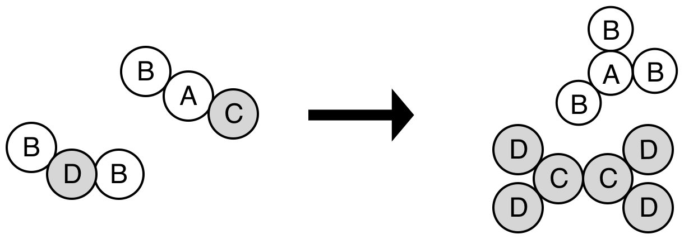

Write the balanced equation for this reaction.

2 H₂(g) + O₂(g) → 2 H₂O(g)

Which of these molecules would be called reactants?

H₂ (hydrogen) and O₂ (oxygen) — the molecules on the LEFT side of the arrow.
3. Balance these reactions.

a. 2 AgNO₃(aq) + 1 CaCl₂(aq) → 2 AgCl(s) + 1 Ca(NO₃)₂(aq)

b. 2 C₂H₆(g) + 3 O₂(g) → 2 CH₃COOH(g) + 2 H₂O(g)

c. 2 HCl(aq) + 1 Ba(OH)₂(aq) → 1 BaCl₂(aq) + 2 H₂O(l)
d. 2 Na(s) + 2 H₂O(l) → 2 NaOH(aq) + 1 H₂(g)

e. When solid potassium chlorate is strongly heated in a flame it forms oxygen gas and solid potassium chloride.

2 KClO₃(s) → 2 KCl(s) + 3 O₂(g)

f. Zinc and lead (II) nitrate react to form zinc nitrate and lead.

Zn(s) + Pb(NO₃)₂(aq) → Zn(NO₃)₂(aq) + Pb(s)

For the following chemical reactions, write the balanced chemical equation, including the energy term where it belongs. Also, complete the energy bar chart, the chemical potential energy graph and indicate if the reaction is exothermic or endothermic.

4. When 3M HCl is added to solid sodium carbonate, the contents of the test tube immediately starts bubbling and gets warm. Carbon dioxide gas, water vapor and sodium chloride are formed.
Balanced equation: 2 HCl(aq) + Na₂CO₃(s) → 2 NaCl(aq) + H₂O(g) + CO₂(g) + energy
Type: EXOTHERMIC (energy is a product — the test tube warms).
Energy bar chart: E_ch of reactants is TALL, E_ch of products is SHORTER; thermal energy of surroundings INCREASES. PE graph: starts HIGH, rises over activation-energy hump, drops to LOWER final PE (ΔPE < 0).
5. As solid ammonium nitrate dissolves in water, the resulting solution cools.
Balanced equation: NH₄NO₃(s) + energy → NH₄⁺(aq) + NO₃⁻(aq)
Type: ENDOTHERMIC (energy is a reactant — the solution cools).
Energy bar chart: E_ch of reactants is SHORT, E_ch of products is TALLER; thermal energy of surroundings DECREASES. PE graph: starts LOW, rises over activation-energy hump, ends at HIGHER final PE (ΔPE > 0).

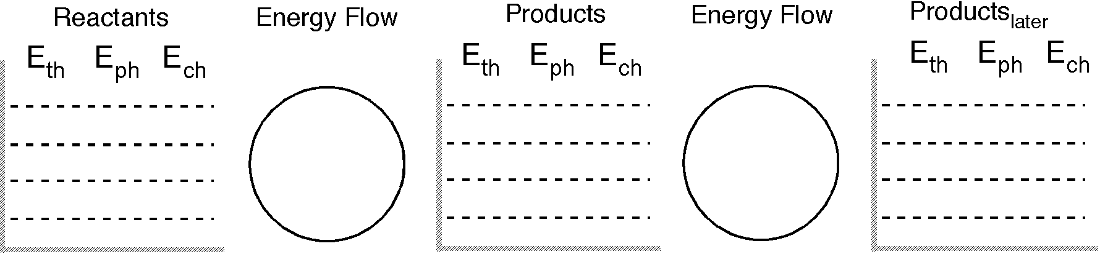

progress of reaction
Ech

6. What type of reactions are the following?
a. MnI₂(s) → Mn(s) + I₂(s) Decomposition
b. C₂H₅OH(l) + 3 O₂(g) → 2 CO₂(g) + 3 H₂O(g) Combustion
c. CaCl₂(aq) + Na₂CO₃(aq) → CaCO₃(s) + 2 NaCl(aq) Double replacement (precipitation)
d. CO(g) + Cl₂(g) → COCl₂(g) Synthesis (combination)
e. Zn(s) + CuSO₄(aq) → Cu(s) + ZnSO₄(aq) Single replacement

